FinRL: A Deep Reinforcement Learning Library for Financial Applications
Introduction
FinRL (Financial Reinforcement Learning) is an open-source library that applies deep reinforcement learning (DRL) techniques to financial market environments. It provides pre-built environments, datasets, and DRL algorithms to help researchers and practitioners develop portfolio allocation strategies. The library leverages cutting-edge machine learning techniques to model financial markets and optimize trading strategies.
Features of FinRL
1. Predefined Market Environments
- Stock Trading Environment: Simulates the buying and selling of stocks based on historical data.
- Cryptocurrency Trading Environment: Designed for digital assets like Bitcoin, Ethereum, and others.
- Portfolio Allocation Environment: Optimizes asset allocation across multiple stocks or financial instruments.
2. Multiple DRL Algorithms
- Deep Deterministic Policy Gradient (DDPG): Used for continuous action spaces, ideal for portfolio optimization.
- Proximal Policy Optimization (PPO): A policy-gradient method widely used for financial decision-making.
- Soft Actor-Critic (SAC): Incorporates entropy regularization to improve exploration.
- Twin Delayed DDPG (TD3): An improved version of DDPG that reduces overestimation bias.
- Advantage Actor-Critic (A2C): A model-free algorithm that balances exploration and exploitation.
3. Data Handling and Preprocessing
- Integrated Data Sources: Fetches historical stock data automatically from sources like Yahoo Finance.
- Technical Indicators: Pre-built indicators like MACD, RSI, and Bollinger Bands for feature engineering.
- Custom Feature Engineering: Users can define their own indicators and transformation pipelines.
4. Backtesting and Performance Evaluation
- Performance Metrics:
  - Sharpe Ratio: Measures risk-adjusted return.
  - Maximum Drawdown: Quantifies the worst peak-to-trough decline.
  - Volatility: Assesses market risk.
- Backtesting Framework:
  - Simulates trading in historical markets to estimate performance.
  - Plots cumulative returns to visualize strategy effectiveness.
5. Modular and Customizable Design
- Modify trading environments, implement new trading strategies, and integrate custom data sources.
- The modular design ensures flexibility for both beginners and advanced users.
6. Open Source and Community Driven
- Actively developed and improved by financial AI researchers and practitioners.
- Community contributions provide pre-trained models, tutorials, and documentation.
Installation
To install FinRL and its dependencies, run the following command:
pip install finrl
Additionally, install the required dependencies:
pip install gym stable-baselines3 pandas numpy matplotlib yfinance
Setting Up a Portfolio Allocation Project
Importing Required Libraries

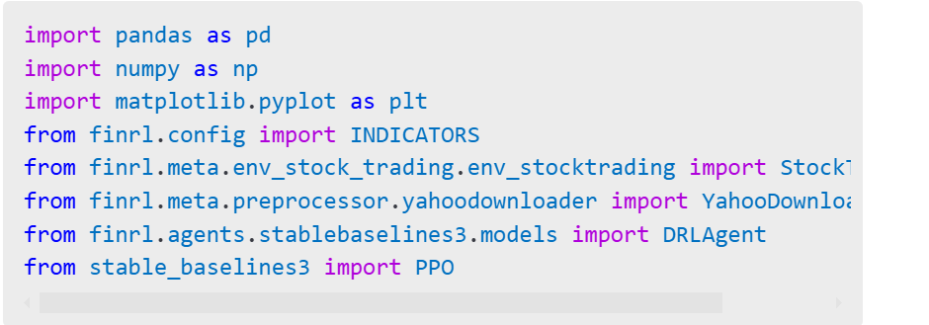
Downloading Market Data

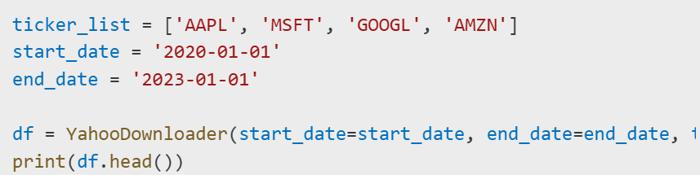
Feature Engineering

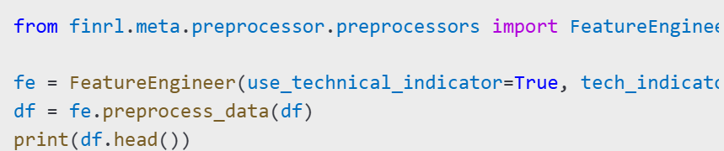

Creating the Trading Environment

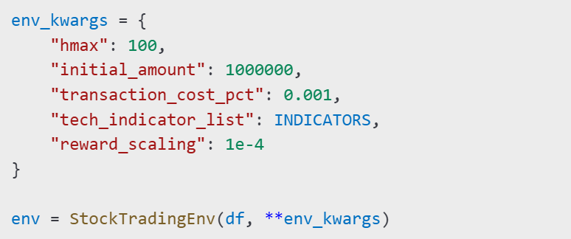

Training the DRL Model

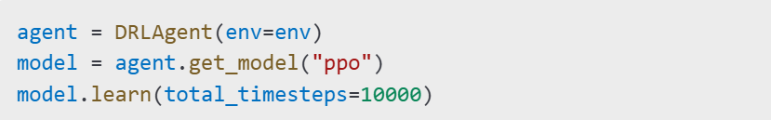

Backtesting the Strategy

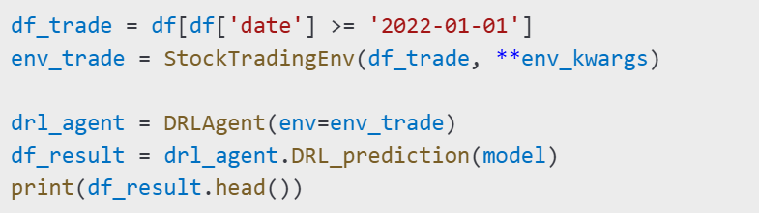

Evaluating the Model Performance

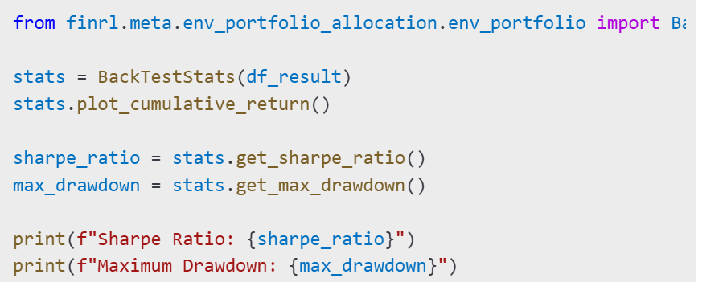

Deploying the Model
Paper Trading: Run the trained model on live market data in a simulated environment before actual deployment.
Live Trading: Integrate with brokerage APIs such as Alpaca or Interactive Brokers for real-time trading.
Conclusion
FinRL provides a structured framework for developing portfolio allocation strategies using deep reinforcement learning. It allows users to collect and preprocess financial data, train reinforcement learning models, and evaluate trading strategies through backtesting. With its modular design, FinRL enables researchers and financial practitioners to build, test, and deploy advanced AI-driven trading algorithms efficiently.

